TacticTool

(draft) User Manual

Introduction

TacticTool has evolved from the wish to be able to analyse sailing performance during and after sailing in parallel with normal navigation. Tactictool offers valuable insights into a yachts performance and provides essential information for decisionmaking and sailtrim during regattas.
TacticTool can be used standalone during round the buoys races, or combined with a chart-plotting program for longer races or passages. TacticTool is also an excellent tool for the cruising yachtsman to establish the proper sailtrim to sail faster.

TacticTool has the following features:
- Digital displays for wind, course, speed, vmg, performance, laylines etc.
- Stripcharts for wind, course, speed, depth, vmg, performance etc.
- Analog displays for wind and performance
- Online polar generation possibility
- Extensive playback features
- Programmable NMEA output for displaying parameters on repeaters
- Fully scalable displays and configurable screen layout
- Tactical display with track, laylines, course etc.

Hardware Installation

TacticTool requires as a minimum an NMEA input with the following sensors:

- GPS (position, course and speed
- Wind (apparent wind and angle)

The following sensors are recommended but not required

- Log (speed)
- Kompas (heading)
- Depth

All NMEA data is expected on one COM port. This means that all sensors will have to be connected to the PC through either a mulitplexer or a server. Below diagram gives an example.

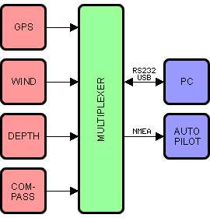

Consult the manual of your instruments to establish the proper connections. A bidirectional connection (RS232 or USB) is required if you want to display performance data on repeaters. Multiplexers which are fully compatible with TacticTool can be found at www.shipmodul.nl

If you want to run a chart-plotter program alongside TacticTool, it is possible to share NMEA data from one COM poort through the program VirtualPlex. This program is supplied on the CD which contains TacticTool. Otherwise you can download it from www.nauticis.com

Software Installation

After inserting the CD-ROM in the drive the installation program will run automatically. If this is not the case run the program setup.exe on the CD-ROM.

After installation it is recommended to restart the PC. Connect all equipment to the PC and start the program. With the first run it is necessary to select the proper COM port. Press the communication button and select the proper COM port and baudrate. Press OK to start communication. Check if all expected data is received. If required it is possible to select different NMEA sentences throught the properties screen. Using the terminal screen you can check if the data is received.

Configuration

The screenlayout of TacticTool is fully configurable. It is possible to move graphs, displays and toolbars and fix them whereever you want by clicking on the edge of the component and dragging it to the required position. By means of the frames button it is possible to turn the components on or off. The size of the components can be changed by floating the component and then change the size on the right/lower edge.

Polar Diagram

In order to enable TacticTool to calculate the relative performance of a yacht considering the windangle and speed, it is necessary to enter a polar diagram. The polar diagram is a projection of the theoretical performance of a yacht at various windspeeds and angles. There are two ways of establishing a polar: Via a theoretical predictions from a VPP (velocity prediction program) or via realtime observations. Data from a VPP can be obtained from an IMS certificate.
Below image shows the difference between a theoretical polar and realtime observations

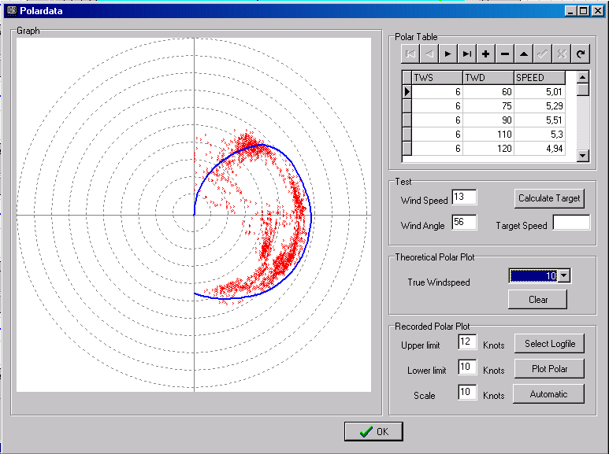
The red dots are observations and the blue line shows the 10knots polar from the IMS certificate of the Dehler 34.

If a theoretical polar is not available the polare will have to be constructed from realtime observations TacticTool offers excellent possibilities for achieving this. Also a theoretical polar can be optimised by entering observations in the polar table.

In order to enter a polar as many measurement points as possible is required. A usual number of 10 different windangles and 8 different windspeeds are normal. The program is shipped with a polar from a Dehler 34, there will be more polars available through internet (www.nauticis.com)

By means of the “+” button a new line can be inserted in the polar table. TWS means “true wind speed”, TWD means “true wind direction” and SPEED is the target boatspeed for that windangle and speed. By pressing the “V” button, the new entry will be stored in the polar table. Make sure that the polar curve is closed, meaning that an entry for 0 and 180 degrees TWD is also required. By means of the “theoretical polar plot” a check can be made if the polarcurve is smooth and complete.

In order to compile a polar based on observations a logfile has to be created first. This logfile is created by pressing the record buttonon the toolbar. Please ensure that the yacht is otimally trimmed and the engine is stopped when recording a logfile. You will need to make many logfile with different conditions to make a reliable polar.

Once a logfile is created this can be analyzed by opening the polar screen , en selecting the logfile. Choose a minimum and maximum windspeed and press “show polar”. The number of observations will depend on the minimum and maximum windspeed setting. If the data is sufficiently reliable you can use this data for updating the polar table. This has to be done manually.

Tactictal Screen

The tactitcal window gives critical information on course, speed, laylines, distance to waypoint and time to laylines etc. The operation of this window is explained below.

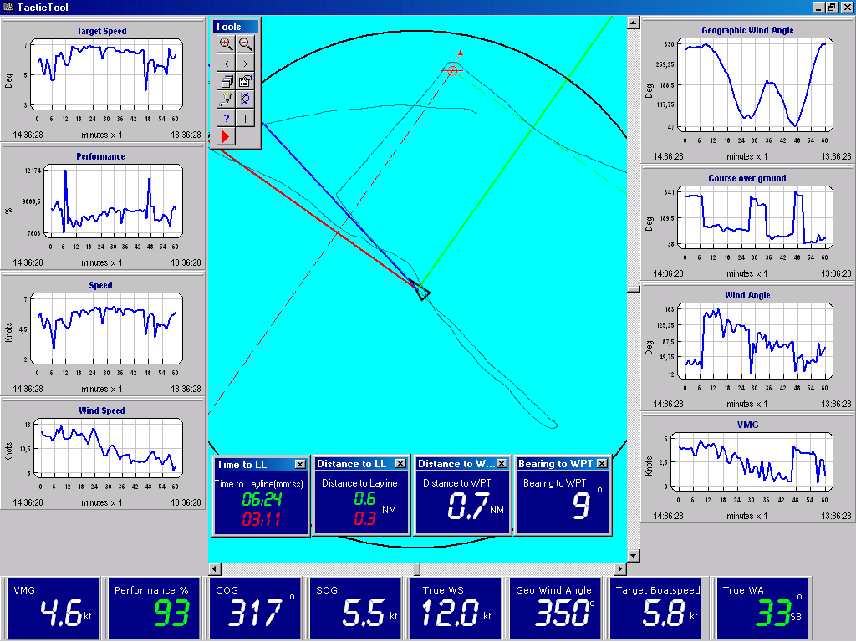

- The black triangle shows the yachts poition.
- The blue line shows the yachts course.
- The red and green line show the tacking angles from the yachts position
- The red and green dotted lines show the laylines from the marker
- The black circle show the position prediction with a configurable interval
- The thin teal line shows the yachts track

The operation of the tactical screen is as follows:

“+”: Zoom in
“-“: Zoom out
Left mousebutton drag: move screen
Right mousebutton drag: select zoom window
Left mousebutton doubleclick: set marker/waypoint

Playback functions

TacticTool has extensive functions to playback a race or passage and analyse it. In order to be able to playback, at first a recording has to be made by pressing the record button while sailing. Try to avoid recording data while using the engine to avoid polution of the data. Once you have recorded a logfile this can be used to cerate a polar diagram or to playback the race or passage. In order to playback actvate the playback toolbar by pressing the “||” button an select a logfile. Logfiles have a “*.db” extension and are named with the date of the recording..

By means of the replay toolbar 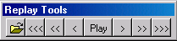 the time can be played forward and backwards. When a logfile is loaded, the recording is at the end of the and has to be rewound to be able to playback.. TacticTool allows playback at normal speed or at 10 times the speed. All controls like zoom-in and zoom-out and data filtering can be adjusted while playing back. The playback can be paused by pressing “play” again. Winding forward and backward can be done in steps of 1 min, 10 minutes and 1 hour.

Data Filtering

From experience it shows that much of the incoming data contains “noise” which makes it difficult to establish trends in for example winddirection. To clean the incoming data, TacticTool contains two kinds of digital filters.
One filter is active on the incoming data, the other can be used on recorded data.

The settings of the filters can be found in the general settings screen.

De instellingen van de filters vindt u in het algemene instellingen scherm:
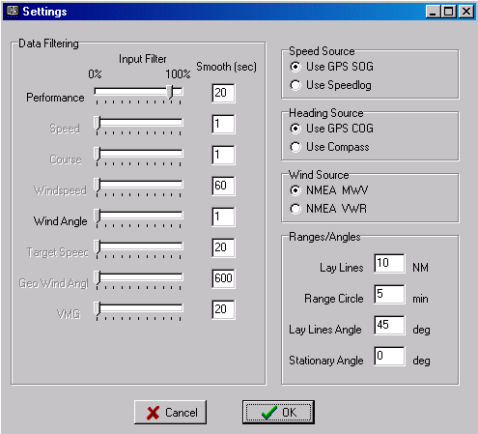

The input filters can be adjusted from the 0% to 100%. The filters are adjusted by the slider. A filter setting of 0% means no flitering and a setting of 100% means no changes are possible. Experience will show the best setting. In general with strong winds the fluctuations are much higher and a higher setting of the filter is recommended. With a high filtering the data will be more steady, but it takes longer for a change to take effect.

The second filter is simple moving average filter. This filter is found under the smooth heading. A setting of 60 means the graph will show the averages over 1 min (60 seconds). Because this filter works on recorded data this filter can be changed later to establish the trends from the data.

Generating NMEA output

Once an accurate polar is established and the program can accurately determine the performance of the yacht, it is very usefull to display the calculated data on a repeater on deck where the crew can see whether the right trim has been reached. In order to achieve this is is necessary that repeaters are available and a bidirectional connection between the PC and the instuments is available. The repeaters can be off the XL type which allows the entire crew to view the trimindicators. TacticTool also allows data to be displayed on simple NMEA repeaters.

The desired parameters 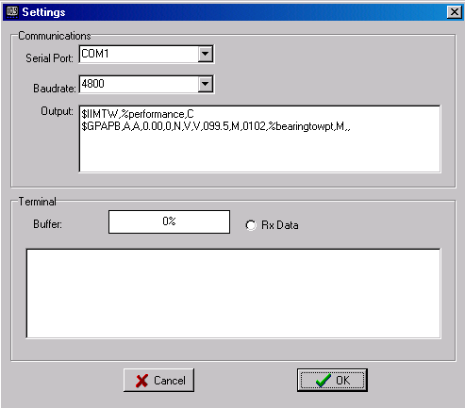are generated by TacticTool by defining NMEA output sentences in the communications screen. The example on the rightside generates an NMEA output sentence by which watertemperature ($IIMTW) is replaced by performance. By selecting the watertemperature on the repeater, the repeater will actually show calculated performance from TacticTool.

Other networks like Silva or NKE contain proprietary NMEA sentences which allow to display target-boatspeed etc. Consult your instrument documentation for more information on possibilities.

The following parameters are supported by TacticTool:

Prestaties: %performance
Peiling naar merkteken: %bearingtowpt
Target bootsnelheid: %targetspeed
Koers: %courseog
Snelheid: %speedog
Windsnelhied: %windspeed
Windhoek: %windangle
VMG: %vmg
Wind over de grond: %windog
Diepte: %depth

When sending NMEA sentences these variables will be replaced by the calculated values at that time.

